PRACTICAL 6

B) **Develop a Simple Room Reservation System Application Using EJB.**

**STEP 1 : COMPLATE THE DATA BASE PART >> GO TO SERVICE >>>>**

**STEP 2 : CLICK ON DATA BASE >>>>> RIGHT CLICK ON MY SQL >>> CREATE NEW DATA BASE >>>name>>> BSCIT**

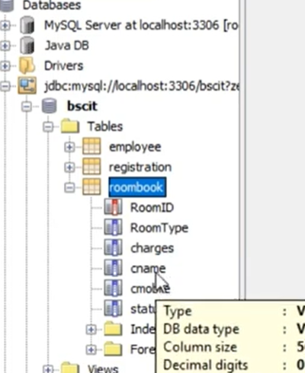

**STEP 3 : RIGHT CLICK ON BSC IT AND CLICK ON CONNECT**

**STEP 4 : RIGHT ClLICK ON BSC IT >>> CREATE TABLE THREE DIFFERENT TABLE>> NAME > TABLE NAME IS 1- employee 2- registration 3- roombook**

**IN ROOMBOOK ADD COLUMN SUCH AS ROOM ID ,ROOM TYPY as per question**

**STEP 5 : RIGHT CLICK ON ROOM BOOK >>> CLICK VIEW DATA and add FEW DATA AS SHOWN BELOW**

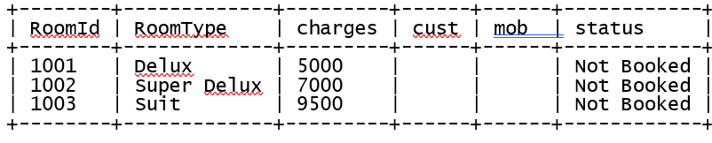

**STEP 6 : GO TO PROJECT >>> CREATE PROJECT >>>> JAVA WEB >>>>WEB APPLICATION >>> FINISHED**

**STEP 7 : PASTE BELOW CODE IN index.html in <body>**

<body>

**<form action="RBServlet" >**

**Enter room Type (Delux / Super Delux / Suit) <input type="text" name="txtType"><br>**

**Enter Your Name<input type="text" name="txtCust" ><br>**

**Enter Mobile No.<input type="text" name="txtMob" ><br>**

**<input type="submit" value="Book Room">**

**</form>**

</body>

**STEP 7: CREATE SERVLET >>> RIGHT CLICK ON PROJECT >>> NEW >>> SERVLET >>> NAME>>> RRBean.java**

package mybean;

import javax.ejb.Stateless;

**import java.sql.*;**

@Stateless

public class RRBean {

**public RRBean() {**

**}**

**public String roomBook(String rt, String cn, String cm)**

**{**

**String msg="";**

**try**

**{**

**Class.forName("com.mysql.jdbc.Driver");**

**Connection con = DriverManager.getConnection("jdbc:mysql://localhost:3306/Logindb","root","root");**

**String query="select * from roombook where RoomType=? and status='Not Booked'";**

**PreparedStatement pst = con.prepareStatement(query);**

**pst.setString(1,rt);**

**ResultSet rs= pst.executeQuery();**

**if(rs.next())**

**{**

**String rno=rs.getString(1);**

**PreparedStatement stm1 = con.prepareStatement("update roombook set cust=? where RoomId=? ");**

**PreparedStatement stm2 = con.prepareStatement("update roombook set mob=? where RoomId=? ");**

**PreparedStatement stm3 = con.prepareStatement("update roombook set status=? where RoomId=? ");**

**stm1.setString(1,cn);**

**stm1.setString(2,rno);**

**stm2.setString(1,cm);**

**stm2.setString(2,rno);**

**stm3.setString(1, "Booked");**

**stm3.setString(2,rno);**

**stm1.executeUpdate();**

**stm2.executeUpdate();**

**stm3.executeUpdate();**

**msg = "Room "+rno+ " Booked .. Charges = "+rs.getString(3);**

**}**

**else**

**{**

**msg = "Room "+rt+ " currently Not available";**

**}**

**}catch(Exception e)**

**{**

**msg=" "+e;**

**}**

**return msg;**

**}**

}

**STEP 8 : CREATE SERVLET >>> RIGHT CLICK ON PROJECT >>> NEW >>> SERVLET >>> NAME>>> RBServlet.java**

package mypack;

import java.io.IOException;

import java.io.PrintWriter;

**import javax.ejb.EJB;**

import javax.servlet.ServletException;

import javax.servlet.http.HttpServlet;

import javax.servlet.http.HttpServletRequest;

import javax.servlet.http.HttpServletResponse;

import mybean.RRBean;

public class RBServlet extends HttpServlet {

**@EJB RRBean obj;**

@Override

protected void doGet(HttpServletRequest request, HttpServletResponse response)

throws ServletException, IOException {

**PrintWriter out=response.getWriter();**

**String rt=request.getParameter("txtType");**

**String cn=request.getParameter("txtCust");**

**String cm=request.getParameter("txtMob");**

**String msg = obj.roomBook(rt, cn, cm);**

**out.println(msg);**

}

}

